INFS 1101 – Lab 21

Instructions

The lab consists of two parts:

* Part I consists of fundamental exercises: you need to complete, understand, and submit these exercises by midnight.
* Part II consists of additional exercises that you need to finish in the next **2 Days** and submit it.

For this lab, you will need to develop a python program for each exercise, the python program should be developed with python IDLE,

Once you are done, put all python files and the traceback word file in two zipped folders (**Lab21-part1.zip)** and (**Lab21-part2.zip)** , submit both parts in the same D2L dropbox.

Part I

## Exercise 1

In this exercise you are given a program called **FineCalculator** that will help a library charges a fine for books returned late. The fine is calculated based on the number of days late. The first 5 days have a lower fine rate, and after that, the fine rate increases.

Assume the user enters the following values:

* Enter the number of days late: 7

**Tasks:**

* Complete the traceback table provided in the lab’s dropbox

Implement the program and submit the py file

## 

## Exercise 2

In this exercise you are given a program called **VendingMachineSoftware** that asks users to input their credit amount. Depending on the users credit it ask him if he want to buy new items and calculate the final number of items purchased.

Assume the user enters the following values:

* Enter your credit amount: $5

**Assume the user decides to buy 3 items.**

**Tasks:**

* Complete the traceback table provided in the lab’s dropbox
* Implement the program and submit the py file

## 

## Exercise 3

In this exercise you are given a program called **CalorieTracker** that asks users to input their current physical activities and duration. The program then calculates the total number of calories.

Assume the user enters the following values:

* Enter the activity (running, cycling, swimming, other): running
* Enter the duration in minutes: 20

**Tasks:**

* Complete the traceback table provided in the lab’s dropbox
* Implement the program and submit the py file

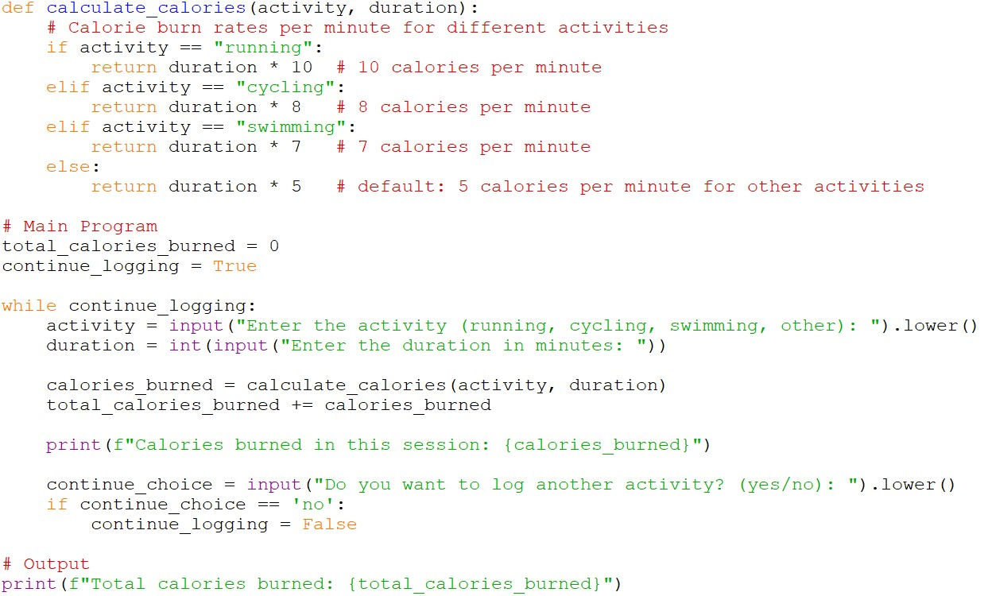

Part II

## Exercise 4

In this exercise you are given a program called **OrdersTracker** that asks users to input the items they would like to order and the quantity. The program then calculates the final cost of the user’s orders.

Assume the user orders 2 burgers, 1 pizza, and then stops,

**Tasks:**

* Complete the traceback table provided in the lab’s dropbox
* Implement the program and submit the py file

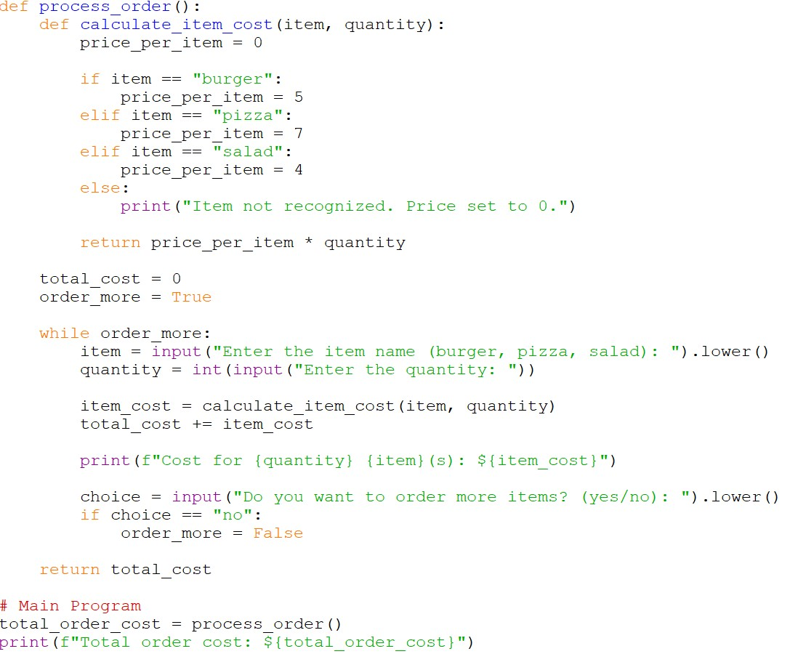

## Exercise 5

In this exercise you are given a program called **MathQuiz** that asks users to input the items they would like to order and the quantity. The program then calculates the final cost of the user’s orders.

Let's say the random questions generated are **3 + 7** (user answers correctly) and **2 * 5** (user answers with 7), then the user decides not to continue.

**Tasks:**

* Complete the traceback table provided in the lab’s dropbox
* Implement the program and submit the py file

